SIMATS ENGINEERING
ASSESSMENT TOOL 3

COURSE NAME: Database Management Systems
COURSE CODE: CSA05
NAME: A. Suraj varma
Reg.No : 192525339

COURSE OUTCOME COVERED

CO2: Apply the relational model, relational algebra, SQL query structures, and views to solve database querying and data manipulation problems. (BL3, BL6)

Activity Tool : Debugging & Optimisation Task (Low)
Assessment Tool Weightage: 30%

QUESTIONS Total Marks: 50
Q.No | Question | Bloom's Level | Marks
1 | Identify and fix the error in the given SQL query that uses incorrect JOIN syntax and returns duplicate results. | BL3 – Apply | 5
2 | The following sub-query returns incorrect results due to a missing correlation. Debug and rewrite it correctly. | BL3 – Apply | 5
3 | A given SQL view definition causes errors when queried. Identify the issue and rewrite a correct and optimized view. | BL3 – Apply | 5
4 | Debug the given relational algebra expression that produces incorrect output for a natural join operation. | BL3 – Apply | 5
5 | The SQL query below violates referential integrity. Identify the violation and modify the statements to enforce proper constraints. | BL3 – Apply | 5
6 | Given an inefficient SQL query with nested loops, rewrite it using JOIN to optimize performance. | BL6 – Create | 5
7 | The GROUP BY query below produces wrong aggregation results. Debug the query and explain the error. | BL3 – Apply | 5
8 | Identify and fix the logical error in a given SQL UPDATE statement that unintentionally modifies all rows in the table. | BL3 – Apply | 5
9 | Optimize the given multi-table SQL query by restructuring sub-queries into JOINs and using appropriate indexes. | BL6 – Create | 5
10 | Debug a given relational calculus expression that returns an empty result set due to incorrect quantifier usage. | BL3 – Apply | 5

Code of Conduct:

I A. Suraj Varma (192525339) (Name / Reg No) certify that this submission is my original work and that I have adhered to the guidelines specified for this assessment.
I understand that any violation of academic integrity rules will result in disciplinary action.

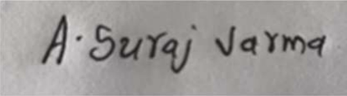
Signature of the student:

RUBRICS FOR CALCULATION:

Criteria | Weightage | Level 4 (Exemplary) | Level 3 (Proficient) | Level 2 (Developing) | Level 1 (Beginning)
Problem Identification | 20% | Accurately identifies all errors and root causes with clear understanding | Identifies most errors with minor gaps | Identifies some errors but misses key issues | Unable to identify errors correctly
Debugging | 25% | Applies systematic debugging techniques effectively to resolve issues | Uses appropriate debugging methods with minor errors | Limited debugging approach; requires guidance | Unable to debug or resolve issues
Optimization | 20% | Optimizes code by significantly improving time complexity using efficient algorithms | Improves time complexity with minor gaps in efficiency | Limited improvement in time complexity | No improvement; inefficient approach retained
Analysis | 20% | Demonstrates strong logical reasoning and clear justification of solutions | Shows reasonable analysis with some justification | Limited analysis; weak reasoning | No analytical reasoning demonstrated
Code Quality | 15% | Produces clean, well-structured code with proper comments and documentation | Code is mostly clear with minor documentation gaps | Code lacks structure and proper documentation | Poorly written code with no documentation

Classroom Allotment System
Q1. Identify and fix the error in the given SQL query that uses incorrect JOIN syntax and returns duplicate results.
Answer:
The error occurs because the tables are joined without a proper join condition. This creates a Cartesian product and produces duplicate or unrelated results.
Incorrect query:
SELECT f.FacultyName, c.CourseName, c.HallNo
FROM faculty f, course c;
The above query does not specify how FACULTY and COURSE are related.
Correct query:
SELECT
f.FacultyID,
f.FacultyName,
c.CourseName,
c.HallNo
FROM faculty f
INNER JOIN course c
ON f.FacultyID = c.FacNo;
Explanation:
The FACULTY table contains FacultyID and the COURSE table contains FacNo. These columns are used to connect a faculty member with the course assigned to that faculty member.
The INNER JOIN returns only the matching records and avoids the unnecessary duplicate combinations.
Result:
The query correctly displays the faculty name, course name and classroom/hall number.

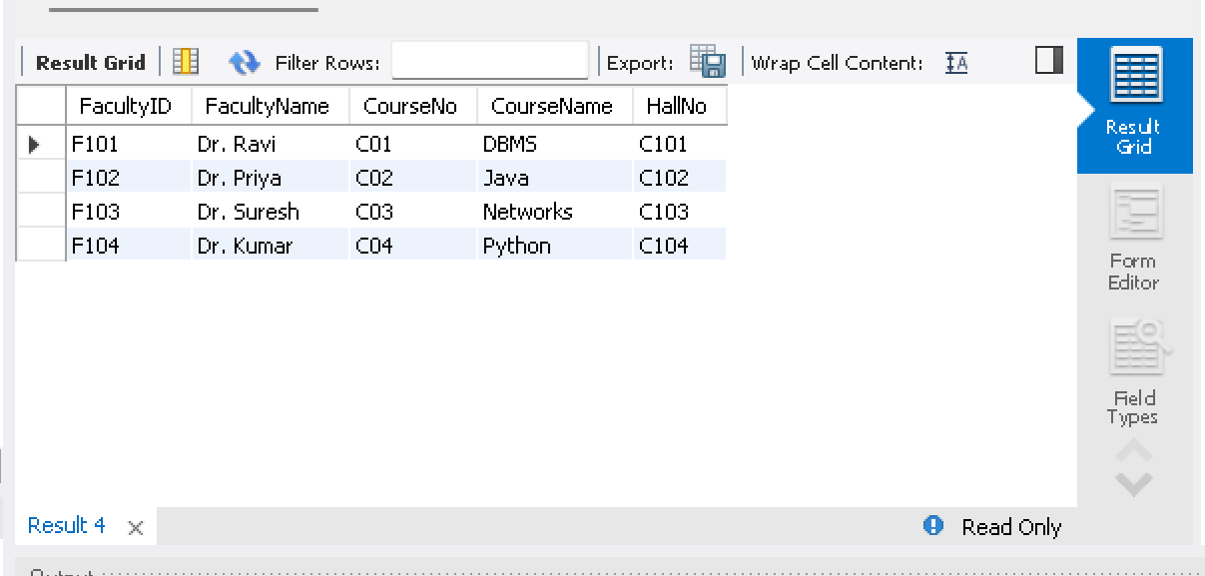

Q2. The following sub-query returns incorrect results due to a missing correlation. Debug and rewrite it correctly.
Answer:
The problem is that the sub-query calculates the average number of students for all faculty members. It does not compare the faculty member with the average of their own branch.
Incorrect query:
SELECT *
FROM faculty f1
WHERE f1.NoOfStudents >
(
SELECT AVG(f2.NoOfStudents)
FROM faculty f2
);
Correct query:
SELECT
f1.FacultyID,
f1.FacultyName,
f1.Branch,
f1.NoOfStudents
FROM faculty f1
WHERE f1.NoOfStudents >
(
SELECT AVG(f2.NoOfStudents)
FROM faculty f2
WHERE f1.Branch = f2.Branch
);
Explanation:
The condition
WHERE f1.Branch = f2.Branch
creates the correlation between the outer query and the inner query.
Now each faculty member is compared with the average number of students in the same branch.
Result:
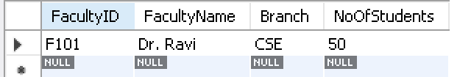
The query displays faculty members whose number of students is greater than the average number of students for their branch.

Q3. A given SQL view definition causes errors when queried. Identify the issue and rewrite a correct and optimized view.
Answer:
The error occurs because the view is using a column that does not exist in the FACULTY table.
Incorrect view:
CREATE VIEW faculty_classroom AS
SELECT FacultyName, ClassroomName
FROM faculty;
The column ClassroomName does not exist in the FACULTY table. The correct column is Classroom.
Correct and optimized view:
DROP VIEW IF EXISTS faculty_classroom;

CREATE VIEW faculty_classroom AS
SELECT
FacultyID,
FacultyName,
Subject,
Classroom,
NoOfStudents
FROM faculty;
To display the view:
SELECT *
FROM faculty_classroom;
Explanation:
The corrected view uses only valid columns from the FACULTY table. It displays the important information required for classroom allotment.
The view is optimized by selecting only the required columns instead of using unnecessary data.
Result:
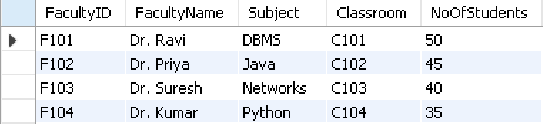
The view correctly displays faculty ID, faculty name, subject, classroom and number of students.

Q4. Debug the given relational algebra expression that produces incorrect output for a natural join operation.
Answer:
A natural join automatically joins relations using attributes having the same name.
In the Classroom Allotment database:
FACULTY contains:
FacultyID
COURSE contains:
FacNo
Although both represent the faculty ID, their attribute names are different.
Incorrect relational algebra expression:
FACULTY ⋈ COURSE
The natural join cannot correctly match FacultyID with FacNo.
Correct relational algebra expression:
FACULTY ⋈ ρ(FacultyID ← FacNo)(COURSE)
The rename operation changes FacNo to FacultyID before performing the natural join.
The relationship becomes:
FACULTY.FacultyID = COURSE.FacNo
Equivalent SQL query:
SELECT
f.FacultyID,
f.FacultyName,
c.CourseName,
c.HallNo
FROM faculty f
INNER JOIN course c
ON f.FacultyID = c.FacNo;
Result:
The faculty and course information is correctly combined using the faculty ID.

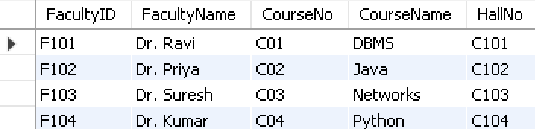
Correct Relational Algebra: FACULTY ⋈ ρ(FacultyID ← FacNo)(COURSE)

Q5. The SQL query below violates referential integrity. Identify the violation and modify the statements to enforce proper constraints.
Answer:
The referential integrity problem occurs when a course contains a FacNo that does not exist in the FACULTY table.
For example:
INSERT INTO course
VALUES
('C05', 'Artificial Intelligence', 'Theory', 5, 'C105', 'F999');
Here, F999 does not exist in the FACULTY table.
Therefore, the COURSE table contains an invalid faculty reference.
First, the FACULTY table should have a primary key:
ALTER TABLE faculty
ADD PRIMARY KEY (FacultyID);
Then create a foreign key in the COURSE table:
ALTER TABLE course
ADD CONSTRAINT fk_course_faculty
FOREIGN KEY (FacNo)
REFERENCES faculty(FacultyID);
Now a valid record can be inserted:
INSERT INTO course
VALUES
('C05', 'Artificial Intelligence', 'Theory', 5, 'C105', 'F101');
An invalid record such as the following will not be accepted:
INSERT INTO course
VALUES
('C06', 'Cloud Computing', 'Theory', 5, 'C106', 'F999');
Explanation:
The foreign key ensures that every FacNo in COURSE must match an existing FacultyID in FACULTY.
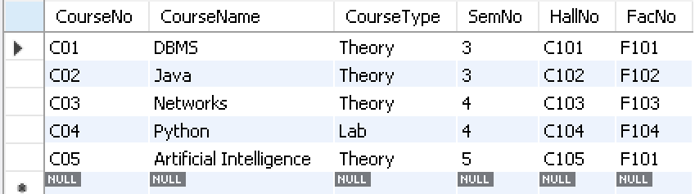
This maintains referential integrity and prevents invalid faculty references.

Q6. Given an inefficient SQL query with nested loops, rewrite it using JOIN to optimize performance.
Answer:
The nested sub-query can be replaced with an INNER JOIN. This makes the relationship between COURSE and FACULTY clearer and can improve query performance.
Inefficient query:
SELECT
CourseName,
HallNo
FROM course
WHERE FacNo IN
(
SELECT FacultyID
FROM faculty
WHERE Branch = 'CSE'
);
Optimized query using JOIN:
SELECT
c.CourseNo,
c.CourseName,
c.HallNo,
f.FacultyName
FROM course c
INNER JOIN faculty f
ON c.FacNo = f.FacultyID
WHERE f.Branch = 'CSE';
Explanation:
The JOIN directly connects the COURSE and FACULTY tables using:
c.FacNo = f.FacultyID
The branch condition is then applied to the faculty table.
This avoids unnecessary nested searching and provides a simpler and more efficient query.
Result:
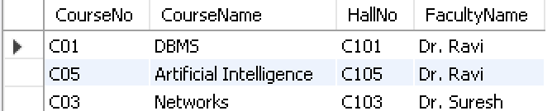
The query displays courses and halls handled by CSE faculty members.

Q7. The GROUP BY query below produces wrong aggregation results. Debug the query and explain the error.
Answer:
The error occurs because FacultyName is selected but is not included in the GROUP BY clause and is not used with an aggregate function.
Incorrect query:
SELECT
Branch,
FacultyName,
COUNT(*) AS Total_Faculty
FROM faculty
GROUP BY Branch;
The query groups records only by Branch but also tries to display FacultyName.
Correct query:
SELECT
Branch,
COUNT(*) AS Total_Faculty
FROM faculty
GROUP BY Branch;
Explanation:
The GROUP BY Branch creates one group for each branch.
The COUNT(*) function counts the number of faculty members in each branch.
Another useful classroom allotment query is:
SELECT
Classroom,
COUNT(*) AS Faculty_Count
FROM faculty
GROUP BY Classroom;
Result:
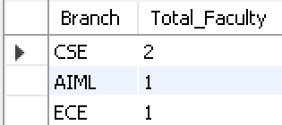
The query correctly displays the number of faculty members in each branch or classroom.

Q8. Identify and fix the logical error in a given SQL UPDATE statement that unintentionally modifies all rows in the table.
Answer:
The error occurs because the UPDATE statement does not contain a WHERE condition.
Incorrect query:
UPDATE faculty
SET Classroom = 'C105';
This statement changes the classroom of every faculty member in the table.
Correct query:
UPDATE faculty
SET Classroom = 'C105'
WHERE FacultyID = 'F101';
To verify the updated record:
SELECT *
FROM faculty
WHERE FacultyID = 'F101';
Explanation:
The WHERE condition identifies the particular faculty member whose classroom should be changed.
Without the WHERE condition, all records are modified.
Best practice:
Before updating, check the required record:
SELECT *
FROM faculty
WHERE FacultyID = 'F101';
Then execute the UPDATE statement.
Result:
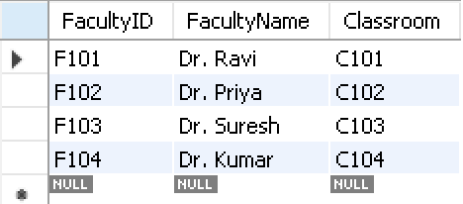
Only faculty member F101 is assigned to classroom C105.

Q9. Optimize the given multi-table SQL query by restructuring sub-queries into JOINs and using appropriate indexes.
Answer:
A multi-table query can become inefficient when several nested sub-queries are used. JOIN can directly connect related tables.
Inefficient query:
SELECT
CourseName,
HallNo
FROM course
WHERE FacNo IN
(
SELECT FacultyID
FROM faculty
WHERE Branch = 'CSE'
);
Optimized query:
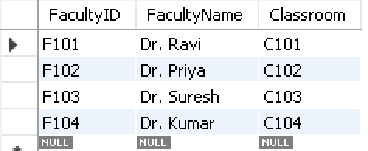
SELECT
f.FacultyID,
f.FacultyName,
f.Branch,
c.CourseNo,
c.CourseName,
c.HallNo
FROM faculty f
INNER JOIN course c
ON f.FacultyID = c.FacNo
WHERE f.Branch = 'CSE';
Create indexes for frequently searched and joined columns:
CREATE INDEX idx_faculty_branch
ON faculty(Branch);

CREATE INDEX idx_course_facno
ON course(FacNo);
Explanation:
The JOIN directly connects the FACULTY and COURSE tables.
The index on Branch helps in searching faculty members by branch.
The index on FacNo helps in matching courses with faculty members.
Therefore, the query becomes clearer and more efficient for larger amounts of data.
Result:
The query displays the CSE faculty members along with their assigned courses and halls.

Q10. Debug a given relational calculus expression that returns an empty result set due to incorrect quantifier usage.
Answer:
The problem is the incorrect use of the universal quantifier ∀.
The universal quantifier means for all. If it is used when only one matching faculty member is required, the condition becomes too restrictive and may return an empty result.
Incorrect relational calculus expression:
{ c |
COURSE(c) AND
∀f (FACULTY(f) → c.FacNo = f.FacultyID)
}
This expression requires the course's faculty ID to match every faculty member.
Correct expression using the existential quantifier:
{ c |
COURSE(c) AND
∃f (FACULTY(f) AND
c.FacNo = f.FacultyID AND
f.Branch = 'CSE')
}
Here, ∃ means there exists.
The expression finds courses for which there exists a faculty member whose FacultyID matches the course's FacNo and whose branch is CSE.
Equivalent SQL query:
SELECT
c.CourseNo,
c.CourseName,
c.HallNo
FROM course c
INNER JOIN faculty f
ON c.FacNo = f.FacultyID
WHERE f.Branch = 'CSE';
Result:
The corrected expression returns the courses handled by CSE faculty members instead of returning an empty result due to the incorrect universal condition.
